**Lemuria – PiN insight**

|  |
| --- |
| **Education PiN definition** The definition agreed globally and as part of the JIAF of a child in need is the following: Number of school-aged children and youths in the areas affected by crisis who do not have access to protective education and acceptable learning conditions, which can negatively impact:   * (i) their physical and psychosocial wellbeing * (ii) cognitive development * (iii) ability to meet their future needs.   The severity of the situation for Education is computed based on 4 dimensions (ALPA): 1) Access to education 2) Learning conditions 3) Protection level in or on the way to school 4) Aggravating circumstances (at individual level)  The table below recaps some examples of indicators falling under each of these dimensions and the main data sources usually available in countries where clusters are activated. The list is not exhaustive, and other indicators deemed appropriate at country level can be used. |

## **Children in Need (5-17 y.o.) in Lemuria**

**41.9% (i.e. 4.1M)** of school-aged children are in need. Among them:

* 2.0M are girls and 2.1M are boys;
* 419.0K are 5 years old (ECE);
* 3.7M are between 6 and 17 years old;
* 410.3K are children with disability.

School-aged children in need, according to population groups:

|  |  |
| --- | --- |
| Population groups | Number of school-aged children in need of education |
| HOST | 2.5M |
| IDP | 1.2M |
| RET | 446.5K |
| TOTAL | 4.1M |

### School-aged children severity distribution

|  |  |  |  |  |  |  |  |  |
| --- | --- | --- | --- | --- | --- | --- | --- | --- |
|  |  |  | School-aged children PiN | | | | | |
| ToT # | Severity levels 1-2 | | Severity level 3 | | Severity level 4 | | Severity level 5 | |
|  | % | # | % | # | % | # | % | # |
| 9.8M | 58.1 | 5.7M | 7.5 | 730.6K | 32.5 | 3.2M | 1.9 | 187.8K |

### Unpacking levels of severity for each population group

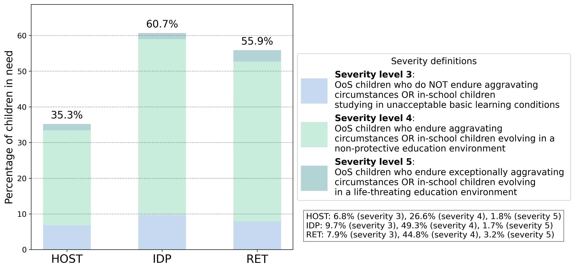

### Unpacking children needs

What is driving the severity of children in needs?

Children in need are categorized based on four key dimensions of the Education People in Need (PiN) framework: Access to education, Learning conditions, Protection level in or on the way to school, and Aggravating circumstances. These dimensions determine their severity level:

* Lack of access to school: This applies to children who fall into severity 3 and are not accessing school at all.
* Studying in unacceptable basic learning conditions: These children are assigned to severity 3, but they do have access to school. However, the quality of their learning environment is extremely poor and inadequate.
* Evolve in a non-protective education environment: Children assigned to severity 4 who are attending school but in an environment that does not ensure their safety or protection.
* Face aggravating circumstances preventing their access to education: Children assigned to either severity 4 or 5, where external factors significantly affect their ability to attend school, leading to a lack of access to education.

|  |  |  |
| --- | --- | --- |
| **Among all children in need (4.1M):** | % | # |
| Lack access to school | 7.6% | 313.5K |
| Study in unacceptable basic learning conditions | 10.2% | 417.1K |
| Evolve in a non-protective education environment | 4.7% | 191.3K |
| Face aggravating circumstances preventing their access to education | 77.5% | 3.2M |

|  |  |  |
| --- | --- | --- |
| **Among HOST children in need (2.5M):** | % | # |
| Lack access to school | 8.5% | 211.9K |
| Study in unacceptable basic learning conditions | 10.8% | 269.8K |
| Evolve in a non-protective education environment | 4.4% | 109.7K |
| Face aggravating circumstances preventing their access to education | 76.3% | 1.9M |

|  |  |  |
| --- | --- | --- |
| **Among IDP children in need (1.2M):** | % | # |
| Lack access to school | 7.1% | 82.9K |
| Study in unacceptable basic learning conditions | 8.9% | 103.0K |
| Evolve in a non-protective education environment | 6.1% | 70.6K |
| Face aggravating circumstances preventing their access to education | 78.0% | 907.0K |

|  |  |  |
| --- | --- | --- |
| **Among RET children in need (446.5K):** | % | # |
| Lack access to school | 4.2% | 18.8K |
| Study in unacceptable basic learning conditions | 9.9% | 44.4K |
| Evolve in a non-protective education environment | 2.5% | 11.1K |
| Face aggravating circumstances preventing their access to education | 83.4% | 372.3K |

### Children's profiles (from MSNA, HH survey)

The graphics below show school-aged children profiles, relying on the 4 dimensions of the education PiN (ALPA, Access to education, Learning conditions, Protection level in or on the way to school and Aggravating circumstances).

